1. **Objectives and Specific Aims**

The overarching goal of the proposed research is to develop a data-driven framework that enables efficient and effective microstructure optimization of additively manufactured (AM) piezoelectric composites. Piezocomposites [1, 2], which consist of a piezoelectric-ceramic phase and an elastic-polymer phase as described in Fig.1, are emerging flexible piezoelectric materials with high efficiency in absorbing and converting multi-directional mechanical stimuli into electrical signals. The piezoelectric properties are dictated by the microstructure, namely, the morphology of each phase [1].

The proposed data-driven framework leverages (1) extensive physics-based simulation data as well as (2) limited amount of measurement data from AM process. It provides an opportunity to bypass the traditional optimization approaches in a computationally efficient manner, while providing complete solutions of optimized microstructures. We have three specific research aims including : 1) to develop a deep learning-based model that provides the mapping of high-dimensional microstructures to low-dimensional design variables, 2) to establish a cost-effective Bayesian optimization framework to obtain the microstructure with desired piezoelectric properties using physics-based simulations, Gaussian Process (GP) metamodeling and data-driven optimization algorithm, to facilitate computationally efficient solution space exploration and microstructure optimization, and 3) develop an experimental data-driven method to explicitly incorporate AM constraints into microstructure optimization.

Piezocompsites

Piezoelectic ceramics

Elastic polymer

**Fig.1.** Construction of piezoelectric composites



**Fig.2**. Flow chart of the data-driven approach for microstructure optimization of AM piezocomposites

The use of data-driven model for microstructure optimization is an innovative concept that will enable the reduction of the dimensionality of the problem space, and dramatically accelerate the microstructure optimization of AM piezocomposites. If funded, it is anticipated that the proposed pioneering research could generate preliminary data that will support the development of competitive research proposals.

1. **Significant results**
   1. **Microstructure regeneration by StackGan**

We have developed an “in-house” framework to reconstruct the widely observed porous microstructure during AM fabrication, based on the open-source “stackgan” code [3]. Fig.3 shows the preliminary results in which both of the grain structures (including grain size, shape, etc.) and the porosity (pore volume fraction and shape) can be well generated.

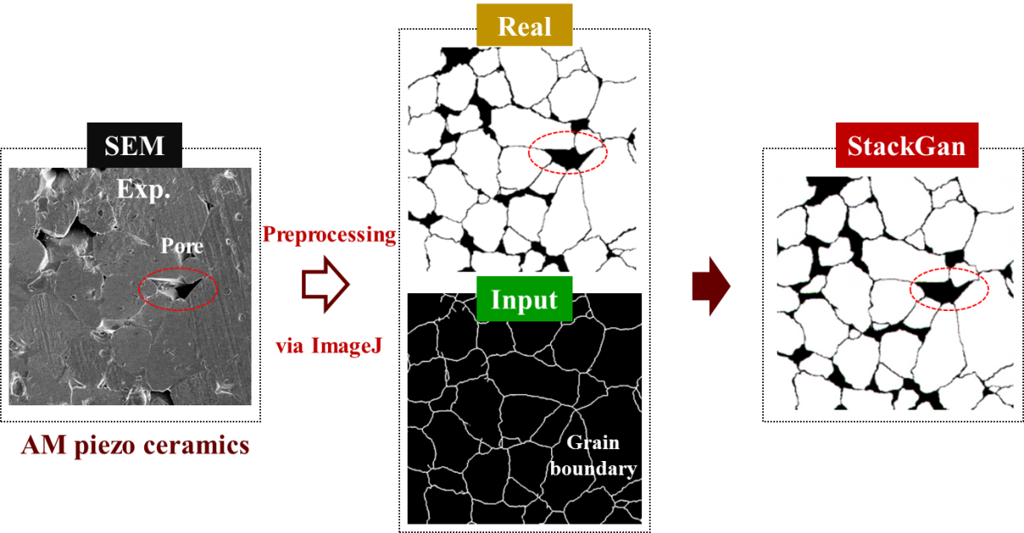

**Fig.3**. Preliminary results of microstructure reconstruction by stackgan [3].

* 1. **Microstructure optimization of AM piezocomposites**

**Fig.4.** Preliminary results of microstructure optimization

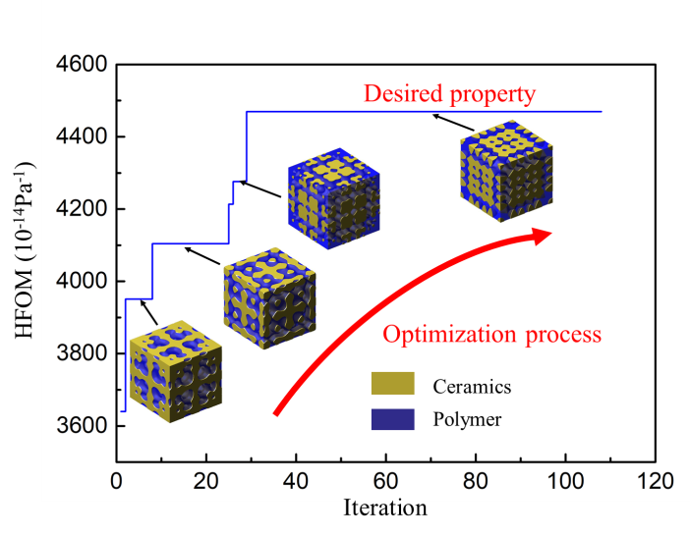

The data-driven computational microstructure optimization of piezocomposites has been performed to inversely identify the microstructures out of innumerable candidates that lead to a desired a combination of properties, e.g., for hydrophone and other related underwater devices, the microstructure optimization process in terms of hydrostatic figure of merit (HFOM), is shown in Fig. 4 [1], where HFOM is expressed as dh ×gh which are respectively the hydrostatic piezoelectric charge and voltage coefficients.

1. **Key outcomes or other achievements**
   1. **Proposals**
2. Supplemental for Collaborative Research: Tuning Piezoelectricity of Bi-continuous Piezocomposites via Additive Manufacturing, In response to NSF DCL "Data Science Activities for the Civil, Mechanical and Manufacturing Innovation Communities". NSF, 2020-2021. Funded.
3. Collaborative Research: Design of Manufacturable Microstructures under Uncertainty for Additively Manufactured Piezoelectric Composites. NSF, 2021-2023. Submitted.
   1. **Publications**
4. W.H. Yang, H. Li, Z. Wang, X. Song*, **L. Chen\***, Statistical modelling of microstructural effects on the effective piezoelectric responses of additively manufactured triply periodic co-continuous piezocomposite. *Acta Materialia*, 2020, submitted.

**References**

[1] Y.Z. Ji, Z. Wang, B. Wang, Y. Chen, T. Zhang, L.Q. Chen, X. Song, L. Chen, Effect of Meso‐Scale Geometry on Piezoelectric Performances of Additively Manufactured Flexible Polymer‐Pb (ZrxTi1− x) O3 Composites, Advanced Engineering Materials, 19 (2017) 1600803.

[2] J. Tressler, S. Alkoy, A. Dogan, R. Newnham, Functional composites for sensors, actuators and transducers, Composites Part A: Applied Science and Manufacturing, 30 (1999) 477-482.

[3] H. Zhang, T. Xu, H. Li, S. Zhang, X. Wang, X. Huang, D.N. Metaxas, Stackgan: Text to photo-realistic image synthesis with stacked generative adversarial networks, in: Proceedings of the IEEE international conference on computer vision, 2017, pp. 5907-5915.